**DIABETES ANALYSIS REPORT**

**1. Problem Statement**

Diabetes is one of the most common chronic diseases globally, characterized by elevated blood glucose levels that can lead to severe health complications if not properly managed. Understanding the factors contributing to diabetes, identifying patterns in patient data, and providing actionable insights can significantly improve patient outcomes and public health strategies.

The diabetes dataset contains key variables that influence diabetes diagnosis and management. However, several challenges hinder the ability to leverage this data for better decision-making:

1. **Early Diagnosis**: Identifying individuals at high risk for diabetes before symptoms manifest remains a challenge. Insights from patient data can help build predictive models for early intervention.
2. **Glycemic Control**: Understanding patterns in blood glucose levels across patient demographics and lifestyle factors is critical for creating targeted intervention strategies.
3. **Patient Segmentation**: Not all diabetic patients exhibit similar patterns; segmentation by age, BMI, glucose levels, or blood pressure can provide more personalized treatment plans.
4. **Correlation with Lifestyle and Clinical Indicators**: Factors like physical activity, BMI, and insulin levels need to be analyzed to determine their impact on diabetes prevalence and progression.
5. **Preventive Measures**: Insights from historical data can help craft preventive care strategies, especially for at-risk individuals.

The goal of this analysis is to extract actionable insights from the diabetes dataset to improve early diagnosis, glycemic control, and personalized care. This data-driven approach can aid in reducing diabetes-related complications and improving patient well-being.

**2. Data Overview**

The diabetes dataset captures patient health indicators and diagnostic information. Key components include:

1. **Pregnancies**: Number of pregnancies for female patients, which is a potential risk factor for gestational diabetes.
2. **Glucose Levels**: Measured blood glucose levels, a primary indicator for diabetes.
3. **Blood Pressure**: Diastolic blood pressure values, often correlated with complications in diabetic patients.
4. **Skin Thickness**: Measures subcutaneous fat and is associated with insulin resistance.
5. **Insulin Levels**: Plasma insulin concentration, an indicator of pancreatic function.
6. **BMI**: Body Mass Index, a critical factor for obesity-related diabetes.
7. **Age**: Provides insights into age-related diabetes trends.
8. **Outcome**: Indicates whether a patient is diabetic (1) or non-diabetic (0).

**Source of Data**:  
The dataset originates from clinical patient records and is structured in CSV format for analysis. The reliability and consistency of the data ensure accurate insights into diabetes risk factors and outcomes.

**3. Understanding from the Data**

**Diabetes Prevalence:**

* **Glucose**: Patients with glucose levels >140 mg/dL have a significantly higher likelihood of being diabetic.
* **BMI**: Individuals with BMI >30 are more prone to diabetes, indicating obesity as a strong contributing factor.

**Key Demographic Patterns:**

* **Age**: The dataset shows a higher prevalence of diabetes in patients above the age of 40.
* **Pregnancies**: Women with multiple pregnancies show an elevated risk of diabetes.

**Lifestyle and Clinical Insights:**

* **Insulin Resistance**: Elevated insulin levels (>200 µU/mL) are observed in most diabetic patients.
* **Blood Pressure**: Higher blood pressure values are common among diabetic patients, necessitating BP management strategies.

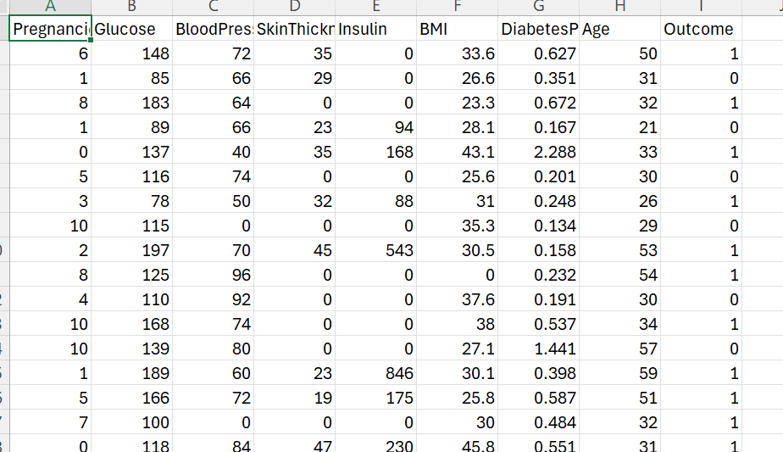

**4. Analysis Conducted**

**Univariate Analysis**

**Objective**: Examine individual variables to identify trends and outliers.

**Example 1: Glucose Levels**

* **Insight**: Patients with glucose >150 mg/dL are predominantly diabetic.
* **Visualization**: A histogram shows the glucose distribution, highlighting thresholds for diabetes.

**Example 2: BMI**

* **Insight**: Majority of diabetic patients have BMI >30.
* **Visualization**: A bar chart displays BMI categories and their diabetes prevalence.

**Bivariate Analysis**

**Objective**: Understand relationships between two variables.

**Example 1: Glucose vs. Outcome**

* **Insight**: As glucose levels increase, the likelihood of a positive diabetes outcome rises sharply.
* **Visualization**: A scatter plot shows a strong positive correlation.

**Example 2: Age vs. BMI**

* **Insight**: Older patients with high BMI (>30) are at greater risk of diabetes.
* **Visualization**: A box plot highlights this trend.

**Multivariate Analysis**

**Objective**: Explore interactions between multiple variables.

**Example 1: Age, Glucose, and Outcome**

* **Insight**: Patients aged >50 with glucose >150 mg/dL show the highest diabetes prevalence.
* **Visualization**: A heatmap captures the interplay of age, glucose, and outcome.

**Example 2: Insulin, BMI, and Outcome**

* **Insight**: High insulin levels combined with BMI >30 are strong predictors of diabetes.
* **Visualization**: A 3D scatter plot visualizes these interactions.

**5. Graphs Created and Their Insights**

1. **Histogram of Glucose Levels**

* **Insight**: Highlights thresholds for diabetes diagnosis.
* **Actionable Insight**: Use glucose >150 as a key cutoff for targeted screening.

1. **Scatter Plot: BMI vs. Glucose**

* **Insight**: Patients with high BMI and glucose levels are predominantly diabetic.
* **Actionable Insight**: Combine BMI and glucose thresholds for risk stratification.

1. **Heatmap: Age, Glucose, and Outcome**

* **Insight**: Visualizes high-risk age and glucose combinations.
* **Actionable Insight**: Prioritize screening for older patients with high glucose.

1. **Line Chart of Diabetes Prevalence by Age**

* **Insight**: Shows an increasing trend in diabetes cases with age.
* **Actionable Insight**: Design age-specific preventive measures.

1. **Box Plot: Blood Pressure vs. Outcome**

* **Insight**: Higher blood pressure is correlated with positive diabetes outcomes.
* **Actionable Insight**: Encourage routine BP monitoring for diabetic patients.

**6. Overall Insights and Solutions**

1. **Identify High-Risk Individuals**: Focus on patients with glucose >150 and BMI >30 for early diagnosis.
2. **Segment Patients by Risk**: Use age and insulin levels to create patient segments for targeted interventions.
3. **Improve Preventive Measures**: Educate younger individuals with moderate glucose and BMI levels to prevent diabetes onset.
4. **Optimize Treatment Plans**: Tailor treatment based on multivariate patterns like insulin resistance and blood pressure.
5. **Encourage Lifestyle Changes**: Promote physical activity and dietary adjustments for patients with high BMI and glucose levels.

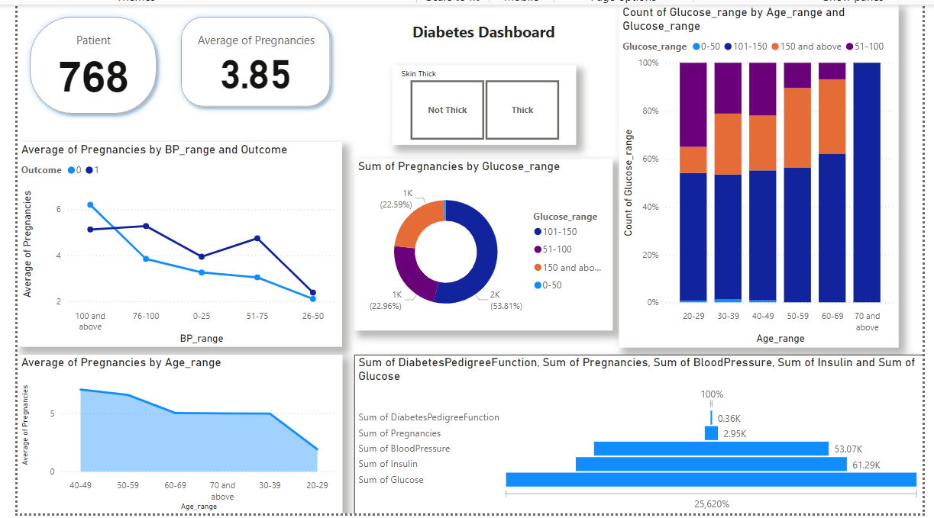

**7. Recommendations for Public Health and Treatment**

1. **Early Screening**: Prioritize glucose and BMI as critical screening metrics.
2. **Targeted Education**: Create awareness programs for high-risk age groups and obese patients.
3. **Personalized Interventions**: Use data-driven insights to offer tailored treatment plans.
4. **Regular Monitoring**: Advocate for regular blood pressure and glucose checks for at-risk populations.
5. **Resource Allocation**: Focus healthcare resources on older adults with multiple risk factors.